**2/14/20**

**To:** K&W Tire – Ken Kline

**From:** Molloy - Dan Molloy, Eleanore Mann

**Subject:** Initial VISION from Molloy

Ken;

I think you have a very interesting business and we are certainly open to working with you on it into the future. We would love to support your efforts to grow your market share and to help your dealer network grow in their own local markets.

Molloy is uniquely situated and ready to provide you with what you need to make a big positive result with your Retail Tire Dealers.

**Initial Thought Process:**

**#1**. We offer every dealer in your network, regardless of their size the ability to participate in **Molloy’s Power Sales Training on Tuesdays and Thursdays**.

](https://www.molloysales.com/power-sales-training-live)

You can learn more here - <https://www.molloysales.com/power-sales-training-live>



Each Auto Repair and Tire Dealer would be able to enroll into a **15 Day Free Trial** and then convert over to a monthly membership model.

**Power Sales Training – Live – with Dan Molloy and Molloy Certified Coaches**, was designed by myself over a 21 year period and is an innovative and extremely effective sales and communication training program. We are changing the way people train for effective sales careers.

**#2.** I will also provide the **K&W Tire inside and outside sales staff with Power Sales Training of their own as well as a license to use ICHYWT! across all marketing channels.**

**K&W is an … *I Can Help You With That Company!* ™**



**#3**. We also feel it would add tremendous value to include in the monthly membership fee access to our **Power Sales Training On-Line University**, which was built for Auto Repair and Tire Dealers. And we will encourage dealers to subscribe to our **YouTube Channel** where we have more than 80 Sales Training videos.

[](https://www.molloysales.com/power-sales-training-university)

You can learn more here - <https://www.molloysales.com/power-sales-training-university>

**#4.** We will allow all of the dealers to enroll in our **TAPPS-Pay** program which will help them grow sales and expand their client base in dramatic fashion. ***This program is a Game Changer!***

**](https://www.tappspay.com/)**

**TAPPS-Pay** is a payment plan system used by service advisors to quickly and efficiently set up payment plans for ‘all customers’ regardless of their credit scores. It also increases the size of a dealers market and includes Power Sales Training.

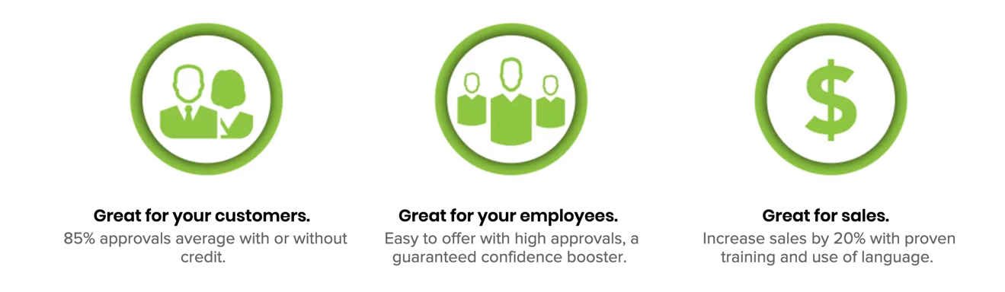

***Service advisors throughout the country participate in TAPPS-Pay training when they are enrolled in the Power Sales Training. They are delivered at the same time.***

You can learn more here - <https://www.tappspay.com/>

**# 5. Branding – K&W TIRES Branding** will be applied as needed to create the connection between **K&W TIRES and the Molloy programs**.



**The plan we’ve outlined above is for EVERY DEALER in the network. At the same time, some of the larger multi-store operations and larger single store dealers can take advantage of Molloy’s entire Business Development Process – Please review the attached BLUEPRINT – 20 PERCENT GROWTH PLAN - DETAIL;**



**30 Day Sales Team Assessment -** <https://www.molloysales.com/30-day-sales-team-assessment>

**Classroom Training** – <https://www.molloysales.com/power-sales-training-classroom>

**Digital Marketing** - <https://www.molloysales.com/digital-marketing-growth>

**Recruitment** **Process** - <https://www.molloysales.com/recruitment>

**CallMaxPlus** - <https://www.molloysales.com/callmax-plus>

**SalesMaxPlus -** <https://www.molloysales.com/salesmax-plus>

In closing, we can be ready in one week to launch a program with you.

Regards



|  |
| --- |
| **Dan Molloy** **| CEO & President** |
| **a:** Molloy Development Group | 812 18th. St. Union City, NJ 07087  **e:** [dmolloy@molloyllc.com](mailto:dmolloy@molloyllc.com) | **w:** [www.molloysales.com](http://www.molloysales.com/)  **p:** 877-212-6001 |